Job Despatch Toolkit for Fleet Management Systems
New Complete Development Toolkit SDK for WinCE Devices and .NET

Add Job Booking and Despatch to existing vehicle tracking systems and Job Management applications

Features
Book and Despatch Jobs
Job Control and Status Messages
Multiple Job Despatch
Navigate To Job
Instant Messaging
Vehicle Tracking

System Architecture

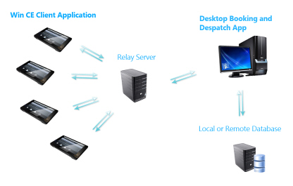

Components

The toolkit consists of 3 main components:

WinCE Client Application for processing Jobs and Vehicle Tracking

IS Intermediate communications server to handle data and job information between desktop booking application and multiple windows CE clients

Desktop Booking and Despatch Application in .NET

Description of Toolkit and Services Provided

A full service can be provided for rapid development of custom applications:

Full Source Code
Wince Devices
Custom Development and Support

System Requirements

For WinCE client - WinCE 6 type device with GPS and GPRS

For IS Intermediate Server - Windows Server with Fixed IP

For Desktop Application - Basic Windows Machine

Prices

Sample Test Kit

Windows CE Device + Software Test Module Setup POA

Full System

Windows CE Client App POA
IS Comms Server Software POA
Desktop Application POA
Wince 6 Devices POA

Custom Development for Server and WinCE or Windows Mobile applications available POA

Appendix A
ScreenShots

