

MTX-HSDPA-EU3 Terminal

Enhance your M2M application into 3G Network

Powered by Cinterion Wireless Module EU3

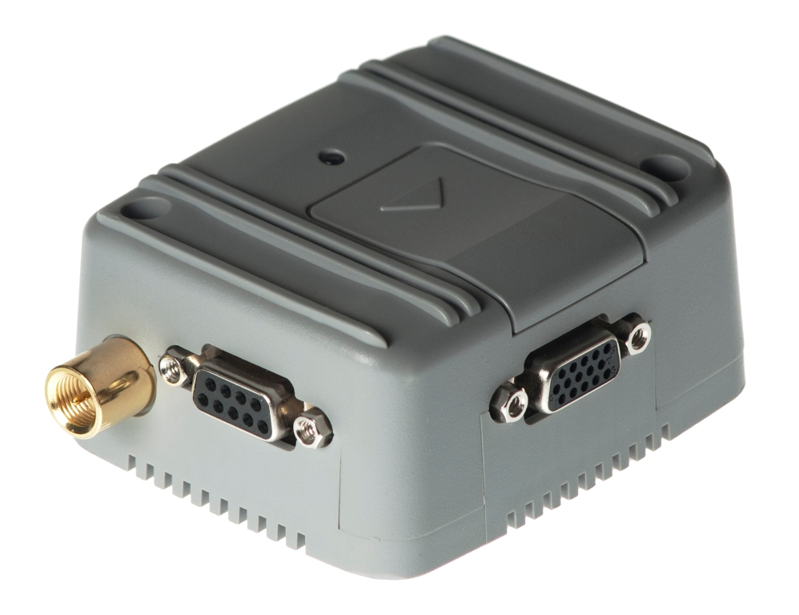
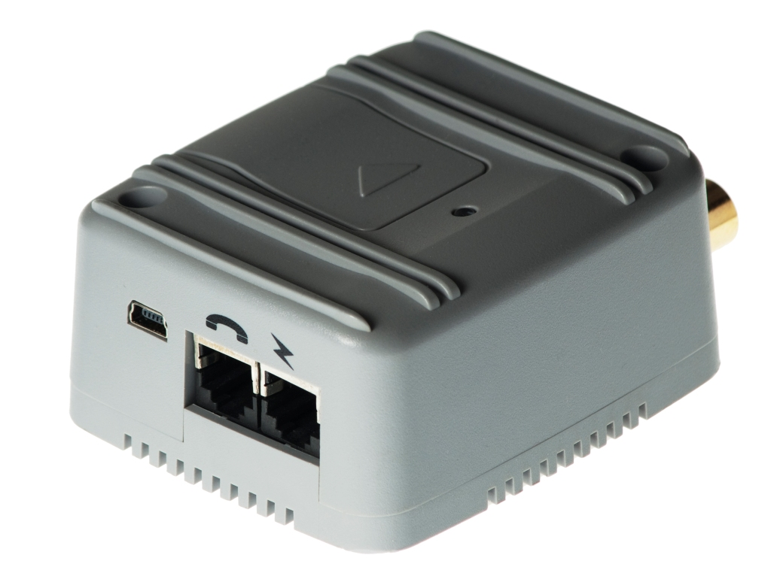
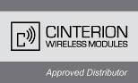




HSDPA
3.6 Mbps
Dual UMTS
900/2100 Mhz
Dual Band GSM 900/1800 MHz
EDGE class 10
GPRS class 10
USB port
RS232 port
Audio analog port
Video call support
4 Input/Outputs
2 Analog Input
TCP-IP stack protocols
When your application needs to receive data up to 3.6 Mbps download or transmit up to 386Kbps the MTX-HSDPA-EU3 terminal is the solution based on HSDPA technology.

The HSDPA (High Speed Downlink Packet Access) is a transmission standard based on the UMTS network which allows a download speed of up to 3.6 Mbit/s. The technology therefore enables services like broadband internet and e-mail access, high-speed download of large data files and streaming of videos or music. MTX-HSPA-EU3 is ready to use in next future UMTS network operating in 900MHz.

The MTX-HSDPA-EU3 is a complete terminal that encapsulates everything you need in one compact plug-and-play unit. The integration is almost not needed because has its own SIM card reader and a USB port, minimizing the need for further hardware components.

The MTX-HSDPA-EU3 is controlled via AT commands in their standard interfaces USB 2.0 full speed (480Mbps) and Serial High Speed up to 460Kbps RS232 port. They can be used at same time.

A complete TCP-IP stack is included so you do not need to have the TCP-IP stack in the controller host, with a simple AT commands you can have powerfull TCP-IP services as socket (server&client), SMTP, POP3, FTP, HTML…

When UMTS-HSDPA network operation is not present, the MTX-HSDPA-EU3 can operate in EDGE class 10 max. 237 kbps (DL), max. 118 kbps (UL) or in GPRS class 10: max. 85.6 kbps (DL), max. 42.8 kbps (UL). The MTX-HSDPA-EU3 can also work in simple CSD data transmission (GSM data rate 14.4 kpbs, V.110, UMTS data rate 57.6 kbps V.120) as well Short Messaging (SMS), and FAX specifications. It has also an analogue interface and capable to make a voice communication call.

MTX-HSDPA-EU3 is RoHs & WEEE compliant and it is manufactured with the ISO 9001 & IS0 14001 Quality certifications

A full list of antennas, cables and supplies accessories are available

www.matrix.es/mtx-terminals

General features:  • HSDPA 3.6 Mbps  • UMTS/HSDPA: Dual band, 900/2100MHz  • GSM/GPRS/EDGE: Dual band, 900/1800MHz  • EDGE (E-GPRS) multi-slot class 10  • GPRS multi-slot class 10  • UMTS/HSDPA 3GPP release 5  • GSM 3GPP release 99  • Output power:  - Class 4 (2 W) for GSM900  - Class 3 (0.25 W) for UMTS/HSDPA  - Class E2 (0.5 W) for EDGE900  - Class E2 (0.4 W) for EDGE1800  - Class 1 (1 W) for GSM1800  • Control via AT commands (Hayes 3GPP TS 27.007 and 27.005)  • Power consumption:  - Power down 50 μA  - Average Supply Current < 970mA (HSDPA data transfer)  • Temperature range  - Normal Operation: -20°C to +65°C  - Restricted Operation: -30°C to +75°C  - Storage: -40°C to +85°C  • Dimensions. Excluding connectors: 78,1 x 66,8 x 37,2 mm  • Weight: < 190 g  • Supply voltage range: 6 ... 30 V | Specification for HSDPA data transmission:  • HSDPA: max. 3.6 Mbps (DL),  max. 384 kbps (UL)  • UE CAT [1-6], 11, 12 supported  • Compressed mode according to 3GPP TS25.212
Specification for UMTS data transmission:
• UMTS: max. 384 kbps (DL), max. 384 kbps (UL)

Specification for EDGE data transmission:
• EDGE class 10: max. 236,8 kpbs (DL),
max. 118 kbps (UL)
• Mobile station class B
• Modulation and coding scheme MCS 1-9

Specification for GPRS data transmission:
• GPRS class 10: max. 85.6 kbps (DL),max. 42.8 kbps (UL)
• Mobile station class B
• Full PBCCH support
• Coding schemes CS 1-4

Specification for CSD data transmission:
• GSM data rate 14.4 kpbs, V.110
• UMTS data rate 57.6 kpbs V.120
• RLP (Non-transparent mode)

Interfaces:  - FME M 50 Ohm antenna connector  - USB 2.0 full speed interface  - Complete 9-pin RS232 @460Kbps port.  - Operating status LED bi-color  - SIM card interface 3V, 1.8 V  - Plug-in power supply and on/off interfaces  - Handset audio interface  - 4 General purpose Input/Outputs  - 2 Analog inputs | Specification for SMS:  • Point-to-point MO and MT  • SMS cell broadcast  • Text and PDU mode
Specification for voice:
• AMR, EFR, FR HR Codecs
• DTMF supported
• CEPT/ANSI supervisory tones supported
• Handset, Headset, Handsfree modes
• TTY supported

Special features:
• Improved power-saving modes
• Firmware update via USB and ASC0
Matrix Madrid | Matrix Barcelona | Matrix Bilbao | Matrix Valencia
Matrix Electronica S.L. | Matrix Electronica S.L. | Matrix Electronica S.L. | Matrix Electronica S.L
C/ Alejandro Sánchez, 109  28019 - Madrid | Pol. Ind. Can Rosés Nave 109, Of. 6-9  08191 – Rubí - Barcelona | Pol. Montorretas  c/ Aliendalde, 11 - Oficina 2G  48200 Durango Vizcaya | Valencia
España | España | España | España
Tel. +34 91 5602737 | Tel. +34 93 5882137 | Tel. 902 198146 | Tel. 902 19 81 46
Fax. +34 91 5652865 | Fax. +34 93 5886172 | Fax. +34 91 5652865 | Fax. +34 915 65 28 65
matrix@matrix.es | aps@matrix.es | bilbao@matrix.es | valencia@matrix.es
Matrix Andalucia | Matrix Aragon |  | Matrix Lisboa
Matrix Electronica S.L. | Matrix Electronica S.L. |  | Lusomatrix, Lda
Sevilla | Zaragoza |  | Av. Coronel Eduardo Galhardo, 7, 1ºC
España | España |  | 1170-105 Lisboa
 |  |  | Portugal
Tel. 902 19 81 46 | Tel. 902 19 81 46 |  | Tel. +351 218162625
Fax. +34 91 5652865 | Fax. +34 91 5652865 |  | Fax. +351 218149482
andalucia@matrix.es | zaragoza@matrix.es |  | comercial@lusomatrix.pt
Ordering information: MTX-HSDPA-EU3: 199801118
HR: 2.01 Firmware 01.014

www.matrix.es/MTX-Terminals
ftp.matrixelectronica.eu/MTX-Terminals
gsmsupport@matrix.es

